HARESTOCK NURSERY

Where every child is unique
Parent and carers Handbook
Our mission
We strive to provide a warm, loving and secure environment where a child’s imagination is supported and not stifled, and where the importance of play and social interaction is seen as more important than being ready for school.

By:
Guiding each child along their own individual learning journey where new experiences and challenges are conquered in a supported environment.
Encouraging parent partnership and active participation in order to optimise the child’s growth and development to reach their full potential.
Providing our experienced team of staff with opportunities to develop and grow with continuous professional development.

Through:
Offering a high quality, safe environment which is consistent to all children throughout their time at the nursery.
Promoting equality to help children develop positive attitudes to differences and see them as normal, familiar, acceptable and useful.
Working within the Statutory Framework and Practice Guidance for the Early Years Foundation Stage.

OUR FACILITY:

Harestock Nursery is set in a convenient location on the outskirts offering 50 places for children from 6 months up to 5 years.
We offer extensive and designated play and engaging learning areas with a large, secure garden designed to develop and inspire the imagination.
An on-site chef will create fresh, nutritious lunches designed for the smaller palate which will be served in the dining room.
The nursery is open 50 weeks of the year, Monday – Friday between 7.30am - 6.00pm, closing for three training days annually, bank holidays, and a two week period over Christmas and New Year.
Our prospectus will only give you a taste of what our nursery provides please bring your child and come along for a visit.

For further information visit our website www.harestocknursery.com Or contact us on Tel:01962 881870/881411
email nursery@harestocknursery.com

Kevin and Julia Kell

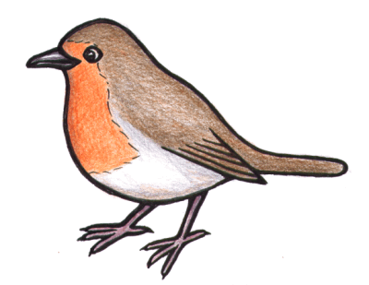The Robins: 6 TO 12 months -
The Robins room is a calm home from home room where we will seek to follow the same routines parents have with their child. Each child will be allocated a key worker who will liaise with the parents and offer continuity for both parent and child and be able to offer the support ensuring the child individual needs are met and supported throughout their time at the nursery, with each daily milestone being recorded in their personal diaries.
Sleeping facilities within the nursery are provided by way of a spacious cot in a warm, quiet and airy room where sleep patterns from home can be followed which can include using the baby’s own comforters and personal items.
We have a pram trail around the garden for walks and an outside play area for babies with the opportunity to interact and socialise with their peers and older children.
Throughout the day the child will explore and be encouraged to develop independence and interests in the discovery of new exciting challenges.
Corresponding with a child’s personal needs and parent wishes nutritious meals can be provided by the nursery which can be pureed, diced etc. Milk and formulas need to be provided by parents.
When a child is ready to move to the next level; Kingfishers toddler room a gentle transition will take place which will incorporate short visits with the key worker and some of their peers where all of the child’s individual needs can be shared with their new key worker. Parents will be kept informed of every step and will be invited to visit and meet the new team.
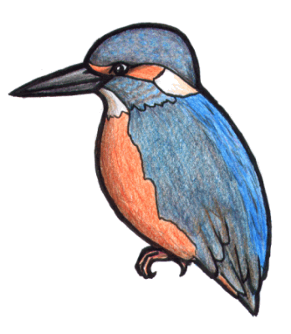
THE Kingfishers: 13 months to 24 months
Kingfishers adopts a free flow approach over two rooms where children will be able to interact with different sensory materials and approach new methods of play through a wide variety of resources. There is a soft play area for discovering balance and stability. The garden has the facilities for small trikes, prams and push along cars.
Each child will be encouraged to participate in painting, puzzles, imaginary role play all designed to enhance their active learning. This will be child initiated and adult led. All children will participate in a daily story time.
Your children will have days where they are busy and fun but they also need time and space to sit quietly, sleep and relax in a calm comfortable setting supported by an experienced qualified team surrounded by friends
All toddlers will be able to sleep after lunch in a warm secure room with their own personal comforters or blankets.
Toddlers wearing nappies will be changed at regular intervals throughout the day or when required, all nappies, creams and wipes are provided by the parents; we can support and advise parents on potty/toilet training and will support the child and parents through this time. Additional clothing is required at this time
We ask that all children have a change of clothes, outdoors coat, and appropriate footwear which is clearly labelled as we will use the garden daily.
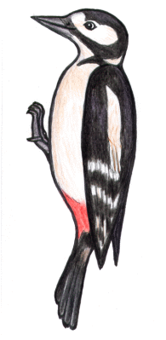
THE Woodpeckers: 25 months to 36 months
The Woodpecker environment is a bright fun filled room with areas for different ages and stages of development. The children will have direct access to the garden and the ability to develop gross motor skills like balance, running, climbing and digging. They can also let off steam
Children will now become engaged in areas of their own personal interest and staff will try and ensure every child takes an active lead in play. The Woodpeckers will start to focus on listening, communication and concentration skills in a range of activities. They will have time to enjoy different textures in creative play from play dough, corn flour, finger painting, threading, weaving. Circle time will become part of the daily routine with song time to help them learn to recite simple rhymes and counting. , story corner which will help children discover their love of books and aid visual
Children will have a freshly prepared lunch and the option to sleep afterwards in our relaxed sleep room dependent on parents’ wishes.
Staff will continue to support and guide with toilet/potty training throughout this transition offering praise and encouragement.
All children aged between two and three will have a progress check by a practitioner to review their progress and parents will be informed of the finding
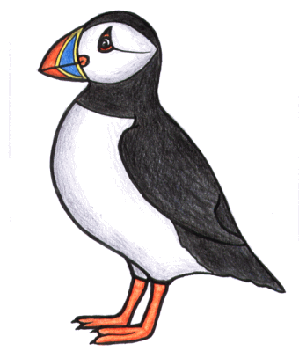
Pre-school Puffins: 3 to 5 years
During the children’s time in the exciting and colourful pre-school room we will offer them a choice of many different areas to play from mark making, messy play, an ever-changing role play area, home corner or just a chance to sit and relax in our comfy story corner with a selection of books.
The extensive garden has a woodland area with outdoor hut, an area to play with bikes, trikes and scooters and a large grass area which will help children with muscle development and give them the chance to run, jump skip and play with their friends.
Our staff will help your child learn to become independent and help to progress their use of letters, sounds and numbers in line with the EYFS (early years foundation stage) and jolly phonics. They will start to try and write letters in their names and in associated words around them
We will seek to stimulate their imagination with a range of daily activities which include the use of colour, music and dance. The children will also be encouraged to start understanding about their own and their peer’s emotions - how they feel, and what makes them feel like that.
Puffins would not normally sleep during the day as preparation for their next step in primary school; but if you would like your child to sleep then please speak with their key worker.
When the time comes for your child to start school we will work closely with you to invite the local school teachers to come and meet the children in an environment they know which will assist the transition in every way possible to ensure they are ready for their next journey in life.

Clothing
Children should come to the nursery in comfortable clothing, which is easily accessible for them when visiting the toilet and is easily removed.
Every child will need a complete set of spare clothes together with coats, gloves, hats and scarves for cold weather and sun hats and labelled sun cream for hot weather.
All clothing should be clearly labelled with your child’s name and kept in a bag on your child’s peg. Please refrain from using plastic carrier bags as these can cause harm to small children.
Children have the opportunity to play with paint, glue and messy items so please do not send your child into nursery wearing special or precious clothing,
Children should wear sensible shoes with backs and have welly boots for the wet days as the children will have the opportunity to play outside in all weather conditions.
Nappies/Potty/Toilet Training
Nappies, wipes, cotton wool and creams need to be provided for your child, they will be kept clearly labelled in their individual boxes. You can provide them daily or weekly.
Babies and toddlers will be changed at regular intervals during the day or when required.
Please inform your child’s key worker when you feel your child is ready to start potty training and we will assist. Please can you ensure we have additional under wear and clothing for children during this period, All of your child’s daily activities will be recorded in the personal diaries for you to see.

Bottles and breast feeding
We are happy for mums to breast feed their children throughout the day. We will also happily store clearly labelled breast milk provided daily in the fridge. We can serve it cold or warmed to body temperature using bottle warmers and warm water. Please note we do not use microwave due to hotspots and a risk of causing harm to the child.
We advise parents to provide pre-made milk in cartons which we will store and serve warm or at room temperature in a sterilised bottle.
If powdered formula is provided parents must make the bottles at home and transport in a cool bag. We will then only store the milk for a maximum of 8 hours stored at 5°C or less. We will then warm and discard after 1 hour.
The government recommendation is that all formula is added to water over 70°C to minimise bacterial infection and not added to pre boiled cold water.
Additional information can be found at:
Start4life guide to bottle-feeding
NHS guide on making infant formula

Nursery meals
The nursery will provide a nutritious balanced diet freshly produced in line with HC3S and comply with the government standards of five a day campaign, every child will receive a mid-morning snack accompanied by milk or water, a hot lunch and pudding, and a mid-afternoon snack, and tea served at 4 o clock.
Drinking bottles for each child will be clearly labelled in their play rooms with fresh drinking water
Please inform your key worker if your child has any allergies or intolerances and we will cater for their individual needs.
All children will sit with their friends at a table to promote socialising, older children will be encouraged to feed themselves, children will be encouraged to taste all food given to them to enhance their palates.
Menus will be placed on our website for you to view
All meals are all included within your nursery fees
Sleeping
At Harestock Nursery we believe all children need to sleep/rest or relax during the day to allow their brains to absorb and develop the day’s events.
Babies (Robins) will sleep in line with their routines at different times throughout the day in cots monitored by staff with their own soothers or comforters.
Kingfishers and Woodpeckers will go to sleep after lunch and can bring in soothers/comforters from home. We will wake the children after two hours unless otherwise requested by parents.
Puffins will not sleep during the day to try and prepare them for school they will have a quite relaxing time after lunch preparing them for the afternoon activities. If you have any individual requests over your child’s sleep patterns please speak to your child’s keyworker.
All sleep patterns will be recorded in individual diaries for you to view.

